ITUE203: WEB DEVELOPMENT FRAMEWORKS 25CS106– Yana


Faculty of Technology and Engineering

Chandubhai S. Patel Institute of Technology (CSPIT) Department of Computer Science & Engineering

Laboratory manual
Academic Year | : | 2026-27 | Semester | : | 3rd

Practical - 09

PROBLEM STATEMENT :
Design the database for StudentHub with students, events and registrations. Create PHP database connection using MYSQL statements
OBJECTIVE:
To design a StudentHub database using MySQL with students, events, and registrations tables, establish primary and foreign key relationships, and create a PHP database connection for efficient and secure data management.

OUTPUT:
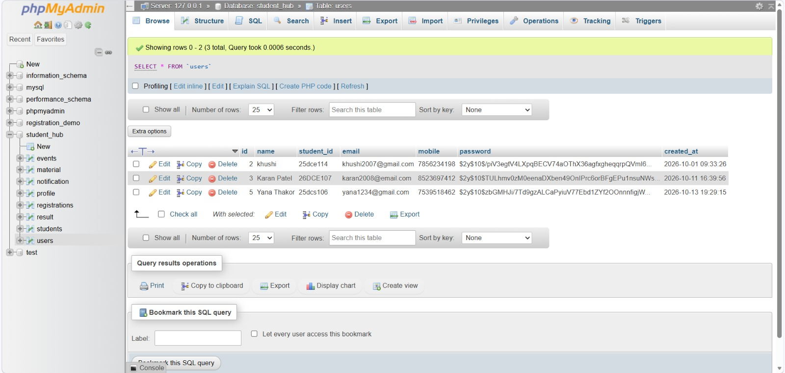

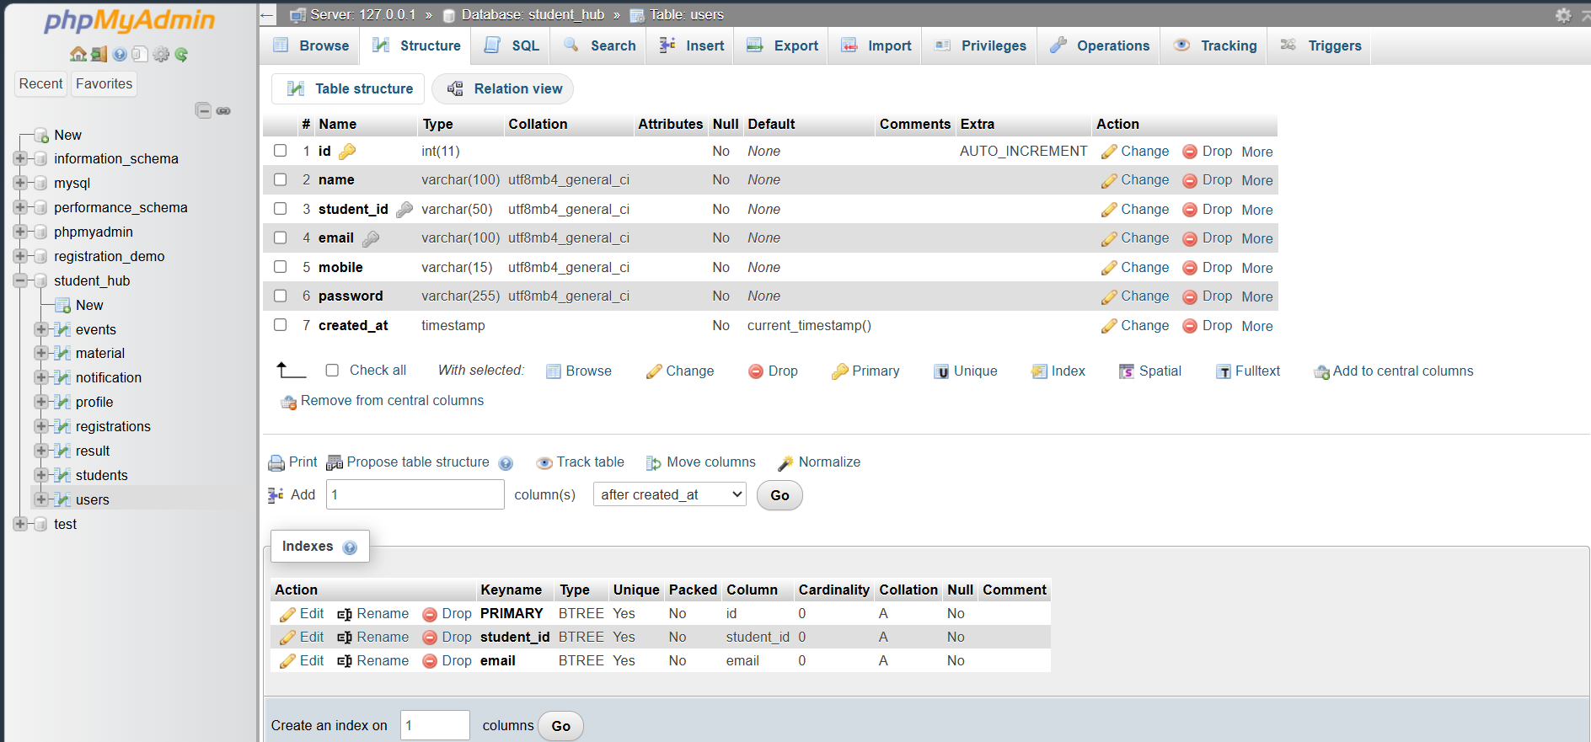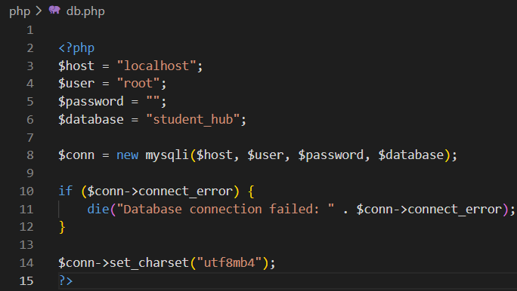

LEARNING OUTCOME:
- Learned to design a MySQL database for students, events, and registrations with proper relationships.
- Learned to connect PHP with MySQL and use prepared statements for secure database operations.

